import smtplib

from smtplib import SMTPException

#this app sends email via gmail

def gmail( ):

usermail = user_email.get()

receivermail=receiver_email.get()

server=smtplib.SMTP('smtp.gmail.com:587')

pass_word=password.get()

subject=subj.get()

#This allow you to include a subject by adding from, to and subject

#line

main_message=body.get('1.0', 'end-1c')

Body="""From: Name here <usermail>

To: <receivermail>

Subject:%s

%s

""" %(subject,main_message )

try:

server=smtplib.SMTP('smtp.gmail.com:587')

server.ehlo()

server.starttls()

server.login(usermail, pass_word )

server.sendmail(usermail,receivermail, Body )

text.insert(1.0, 'message sent')

#error handling

except (smtplib.SMTPException,ConnectionRefusedError,OSError):

text.insert(1.0, 'message not sent')

finally:

server.quit()

def add():

file = filedialog.askopenfilename()

lb8.configure(text="E-Mail Attached !!")

txt6.insert(window,file)

#Gui interface

from tkinter import*

from tkinter import filedialog

root= Tk(className=" Gmail app " )

root.config(bg="brown", )

#user mail

user_email = Label(root, text="Enter your Gmail address: ")

user_email.pack()

user_email.config(bg="black", fg="white")

user_email = Entry(root, bd =8)

user_email.pack(fill=X)

#receiver email

receiver_email = Label(root, text="Enter the recipient's email address:")

receiver_email.pack( )

receiver_email.config(bg="black", fg="white")

receiver_email = Entry(root, bd =8)

receiver_email.pack(fill=X)

#subject line

subj= Label(root, text="Enter your subject here: ")

subj.pack( )

subj.config(bg="black", fg="white")

subj = Entry(root, bd =8)

subj.pack(fill=X)

#Body of the message

text= Label(root, text="Enter your Email text here: ")

text.pack( )

text.config(bg="black", fg="white")

body = Text(root, font="Tahoma", relief=SUNKEN , bd=8)

body.config(bg="pink", height=15)

body.pack(fill=BOTH, expand=True)

#password widget

password = Label(root, text="Enter your Gmail password: ")

password.pack()

password.config(bg="black", fg="white")

password= Entry(root, show='*', bd =8)

password.pack(fill=X)

#Attachment

attachment = Button(root, bd =8, text="Click here to Add the Attachment",

command=add)

attachment.pack(fill=X)

#submit button

submit_mail = Button(root, bd =8, text="Click here to submit the mail",

command=gmail)

submit_mail.pack(fill=X)

#feed back

text = Text(root, font="Tahoma", relief=SUNKEN , bd=8)

text.config(bg="pink", height=2)

text.pack(fill=BOTH, expand=True)

root.mainloop()

**OUTPUT:-**

**GUI Interface**

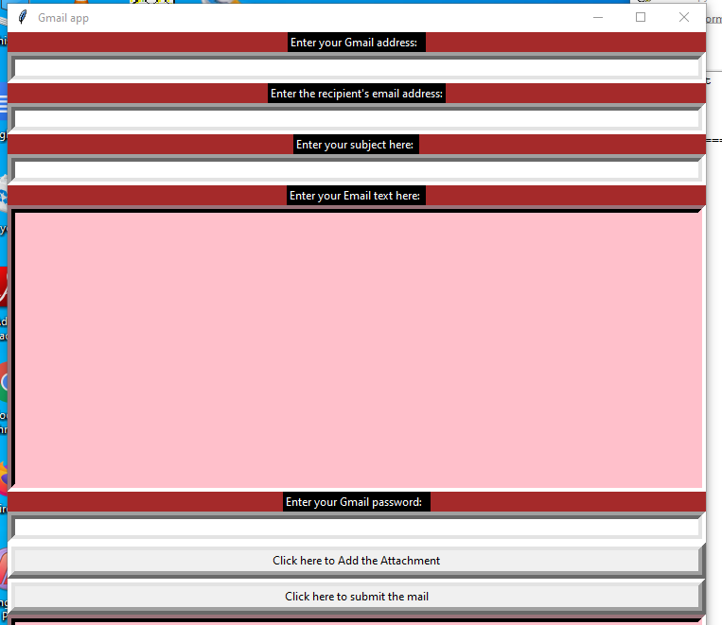

**ATTACHMENT OF FILE**

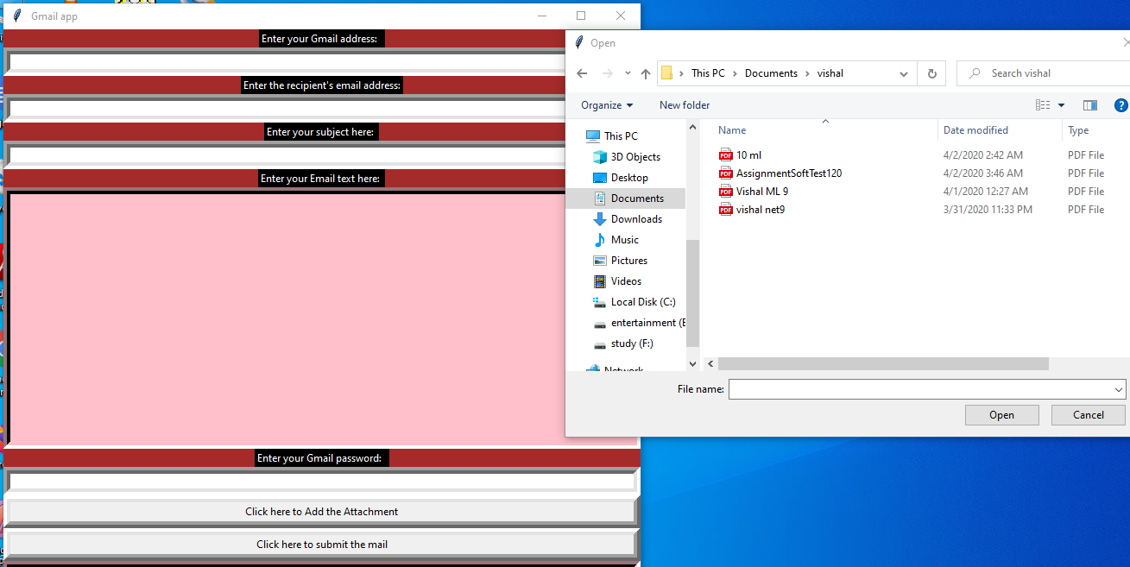

**SENDING An MAIL**

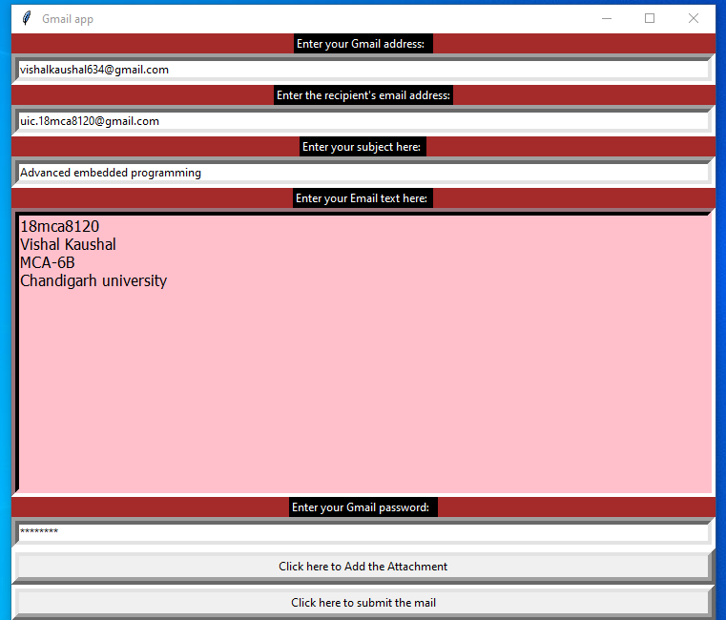

**E MAIL RECIVED**

